IST 736 – Text Mining

**Twitter Text Mining -Climate Change**

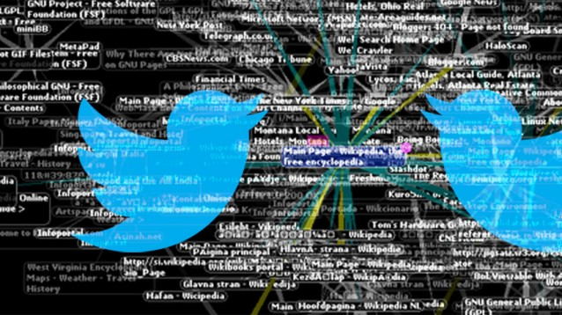

**Professor**: Ami Gates

**Submitted By**: Group 5 – Benjamin Cowan, Brandon Smith, Kathryn Egan, Silki Kaur

Table of Contents

Introduction 3

Motivation 5

Problem Statement 5

About the Data 6

Data Preparation 11

Analysis & Models 11

Supervised Learning Models 11

Naïve Bayes (NB) 11

Support Vector Machine (SVM) 12

Sentiment Analysis 12

VADER Sentiment Analysis 12

Latent Dirichlet Allocation (LDA) for Topic Modeling 12

Time Series Analysis 12

Auto-Regressive Moving Average Model (ARMA) 12

Results 12

Naïve Bayes for Predicting Year of Text 12

Support Vector Machine for Predicting Year of Text 13

MNB and SVM for Predicting Sentiment in 2016 Tweets 13

ARMA for Predicting Future Emissions and Behaviors 18

Conclusions 21

# Introduction

Climate change (NASA, 2021) refers to the long-term change in the average weather patterns that have effect on Earth’s local, regional and global climates. Changes observed in Earth’s climate since the early 20th century are primarily driven by human activities, particularly fossil fuel burning, which increases heat-trapping greenhouse gas levels in Earth’s atmosphere, raising Earth’s average surface temperature. These human-produced temperature increases are commonly referred to as global warming. Natural processes can also contribute to climate change, including internal variability and external factors such as volcanic activity, changes in the Sun’s energy output, variations in Earth’s orbit.

Scientists use observations from the ground, air and space, along with [theoretical models](https://climatekids.nasa.gov/climate-model/), to monitor and study past, present and future climate change. Climate data records provide evidence of climate change key indicators, such as global land and ocean temperature increases; rising sea levels; ice loss at Earth’s poles and in mountain glaciers; frequency and severity changes in extreme weather such as hurricanes, heatwaves, wildfires, droughts, floods and precipitation; and cloud and vegetation cover changes, to name but a few.

In 1975, the term “global warming” was introduced to the world by scientist Wallace Broecker (Black, 2013). Since then, the term has taken on both social and political significance and most recently has become a point of divisive debate.

Global warming is a very broad and constantly changing topic. Therefore, it is easy to miss news or public opinion about it. For people interested in keeping up-to-date, main global warming themes should be created to brief them. This could contain new global warming-related research and public sentiment towards it. Generally, feelings towards global warming are negative because of its detrimental impact on the world. However, there is a lot of optimistic news, such as The United States rejoining The Paris Climate Agreement, that spreads positive sentiment. Furthermore, researching older topics, about global warming, could be indicative of its evolution overtime. For example, Al Gore held the first ever congressional hearing in 1976. Today, global warming continues to be a heated topic as Americans debate the future of hydraulic fracturing (fracking). Regarding fracking, it’s a very controversial topic because many families rely on fracking-related jobs.

Figure 1

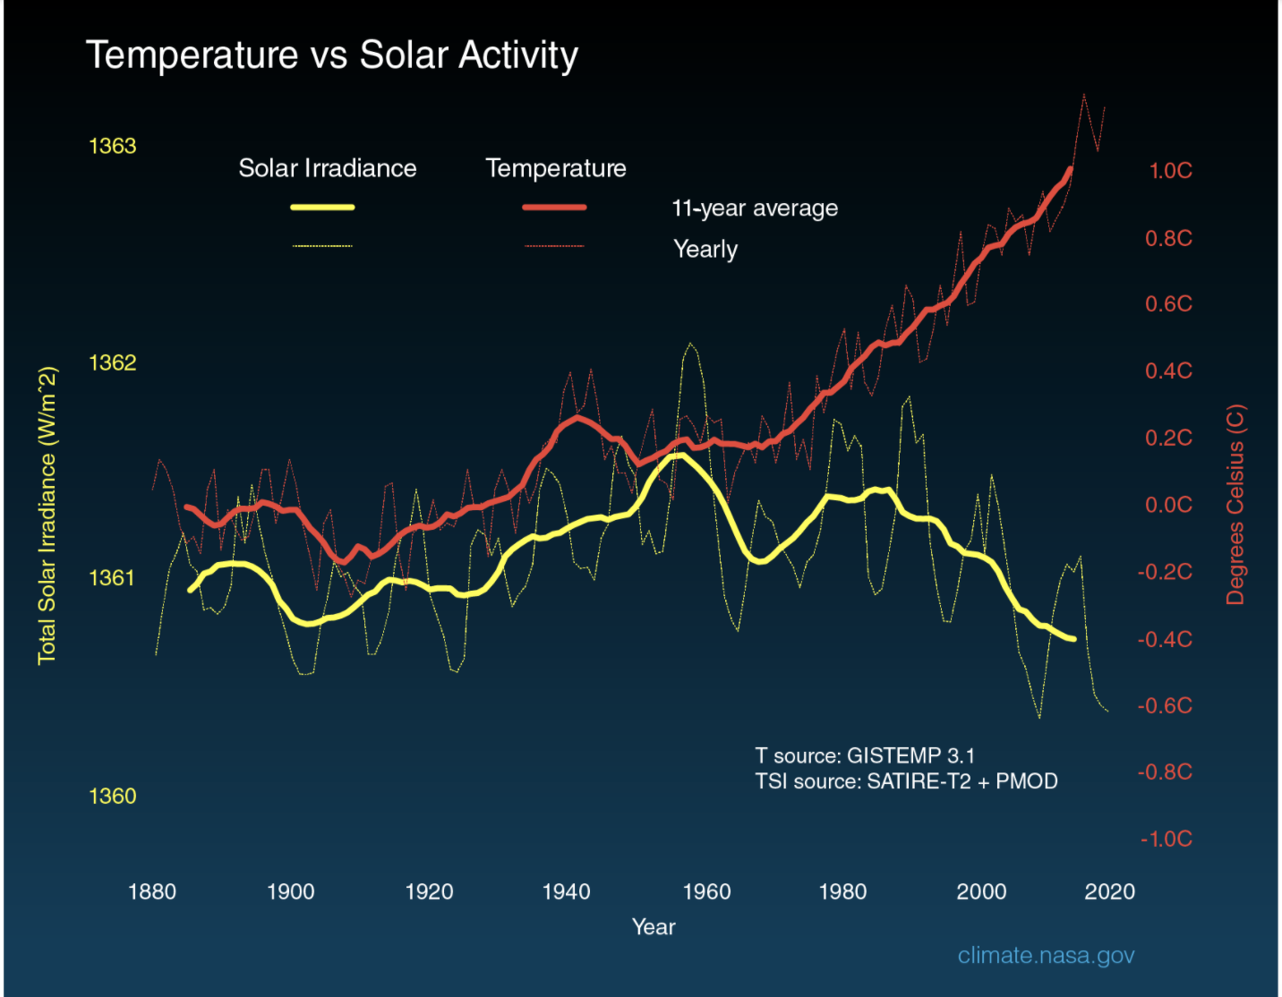

For this project, intent is to analyze the public tweets from 2016 till 2020 to understand how general sentiment has changed over the years around climate change. Is it considered as a hoax or there is actual data to back up that climate is changing, and it is important for us all to understand how it will impact in the coming years? In addition to the twitter data, we also retrieved data from Federal Reserve Economic Data (FRED) API for emissions rate of the top countries contributing to the environment. From the Figure below, it is evident how political figures influence the rate of tweets & discussions around climate change.

It is also noteworthy that shift in people’s opinion of the climate change had nothing to do with the actual facts around changing environment such as heat waves, hurricanes, storms, tornadoes etc. It was purely based on the information publicized on the social media which is scary as it has led to the divide in beliefs and igniting the feeling of considering climate change effects are superficial money draining scheme.

Figure 2

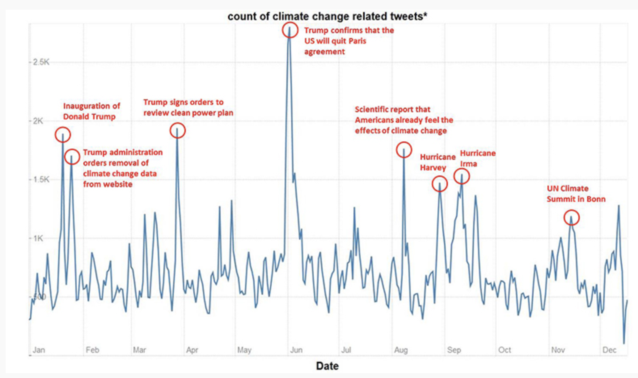

# Motivation

Efforts to make changes for climate change are discussed and carried out by multiple countries across the globe, however, to observe the changes in the atmosphere it takes several years and does require steps for the continuous improvement. While it’s clear that climate plays an important role in our survival, still many countries are putting it on the back burner. Our team wanted to analyze how people’s sentiment have changed over the last few years, given that many political figures consider climate change a hoax. It was interesting to understand how people used to care more about climate in 2016 when compared to 2020. Also, the overall impact of the emissions is significant on the climate.

# Problem Statement

Our analysis involved classification models and predictions based on the tweets and emission rate data to analyze the general public sentiment towards climate change. The aspirational outcome would be to enable our generation to see how social media platforms such as Twitter and political figures & celebrities are influencing how people think about the climate change. Rather than analyzing the impact of climate changes based on the facts, most of the people tend to make up their mind based on the news or social media outlets and do not perform needful actions required to ensure we live in a safe climate.

# About the Data

To compare change in sentiment surrounding climate change over a four-year period, tweets from 2016 and 2020 were compiled from Twitter. The 2020 data was pulled using a twitter API and then coupled with a larger 2020 twitter dataset from Kaggle due to pull limits of the API. The 2016 tweets were downloaded from vicinitas.io, a twitter analytics tool that can pull historic tweets by hashtags.

The hashtags used for identifying tweets for analysis included the following:

* #climatechange
* #globalwarming
* #parisclimateagreement
* #parisaccord

Figure 3

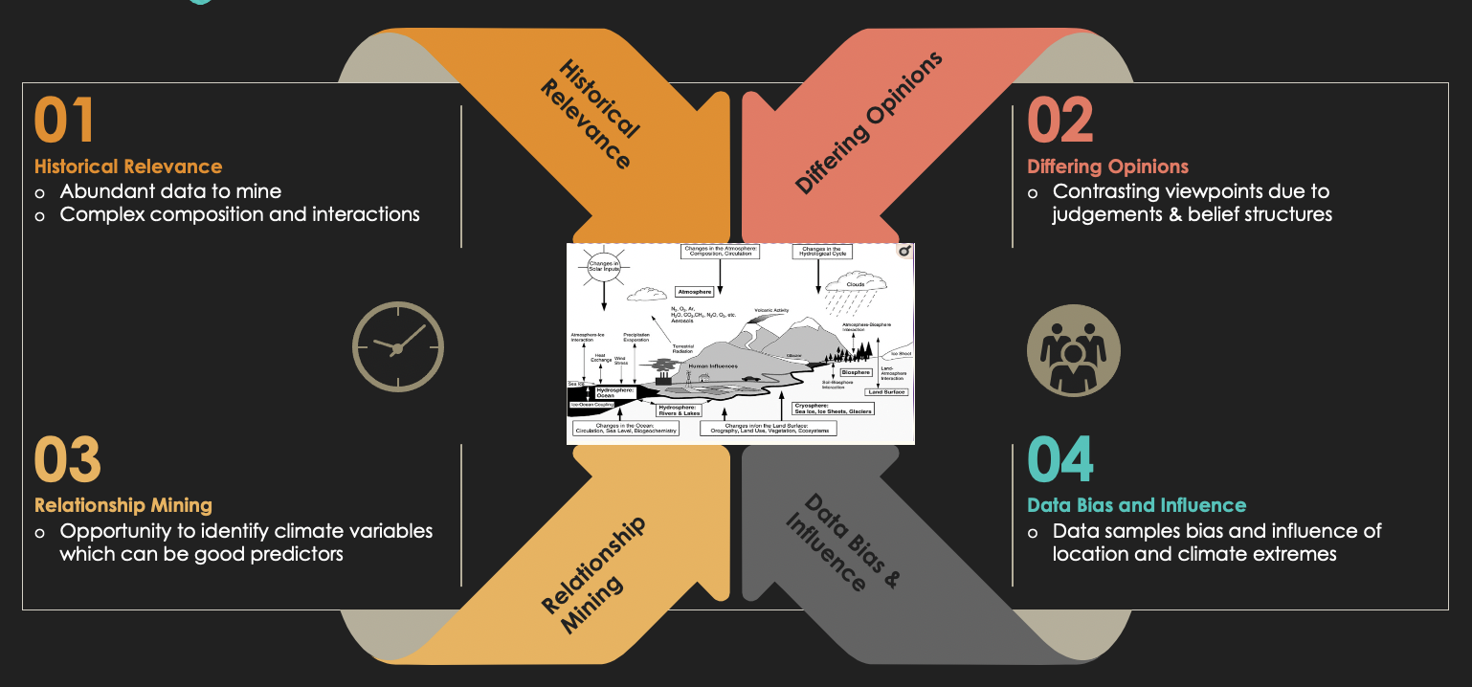

Exploratory Data Analysis (EDA) was conducted on the twitter dataset consisted of 5000 rows and 23 columns. Pandas profiling package was used to create report for the dataset and understanding the anomalies. Strong correlation was observed between “favorites”, “retweet” and “like” columns which do indicate that people tend to reply or retweet on their favorite tweets.

Figure 4

As with every dataset, there were missing cells for fields such as place, latitude, longitude etc. This is justified as Twitter does not impose people to share their location while posting the tweets so many users tend to not disclose their location.

Figure 5

Below are the details on the missing data fields focused on the geography of the tweet:

Figure 6

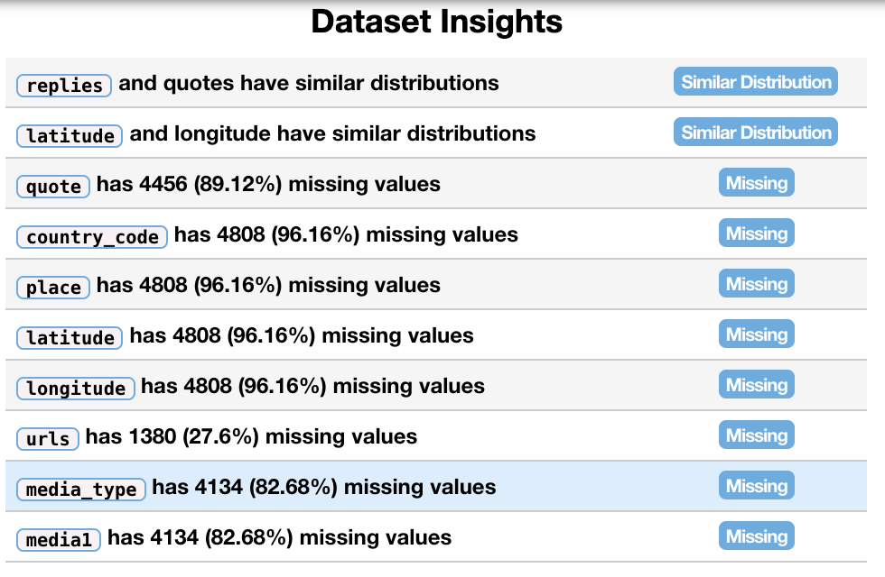

One of the interesting trends shown by the data was around the sources of the tweets, see the breakdown below which provides an overview of the sources from where the tweets are posted by the people. Many sources are obvious such as Web, iPhone, Android, Instagram, Facebook etc. but sources which were shown as anomalies are social apps such as hootsuite, buffer, twitter feed etc. as they enable bots to post scheduled tweets and reply on the tweets as well similar to a real person. As next step, we tried to predict if based on the tweet text we can determine if it was posted by a bot or an actual person. Support Vector Machine (SVM) algorithm was used to predict the tweets text source, but the accuracy obtained was only ~39% which indicates that the tweets posted by the bots mimic closely the way humans write.

Figure 7

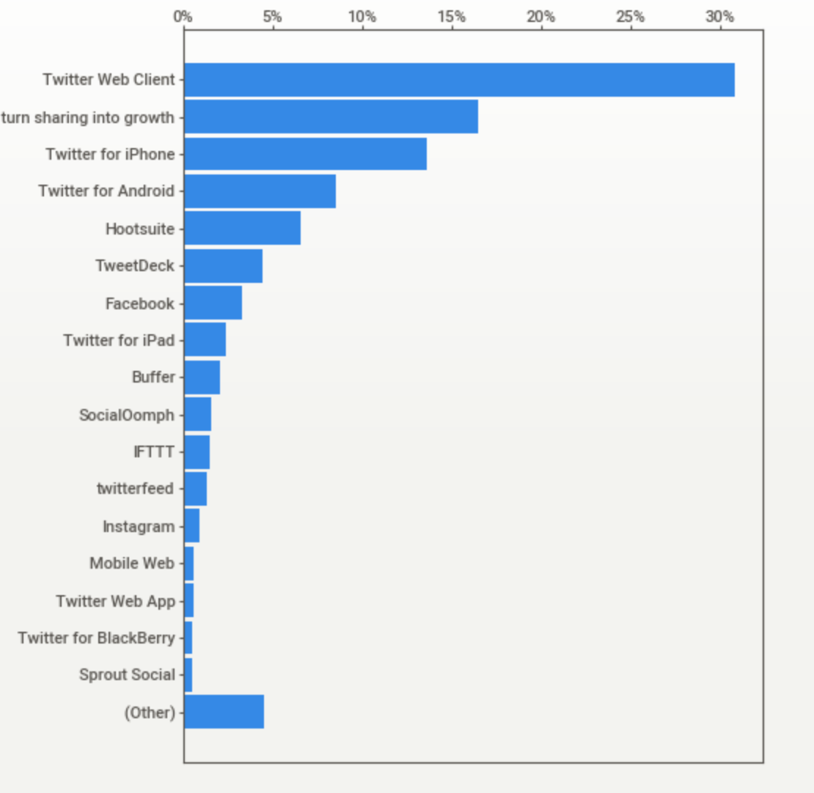

Figure 8

Classification report for predicting tweets posted by the bots is shown below.

Figure 9

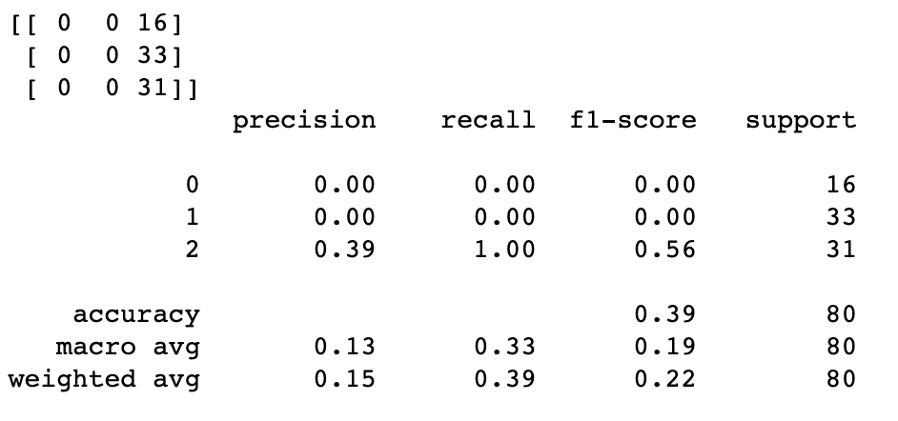

The CO2 emissions data used for future forecasting were collected from a GitHub repository maintained by Our World in Data ([view here](https://github.com/owid/co2-data)). The data for US consumption also used for future forecasting was sourced from the Federal Reserve Bank of St. Louis using its Python API ([view here](https://fred.stlouisfed.org/series/PCECA)). The first step in the exploratory process was to view the relevant data. Here is a graph of the four largest CO2 emitting countries:

Figure 10

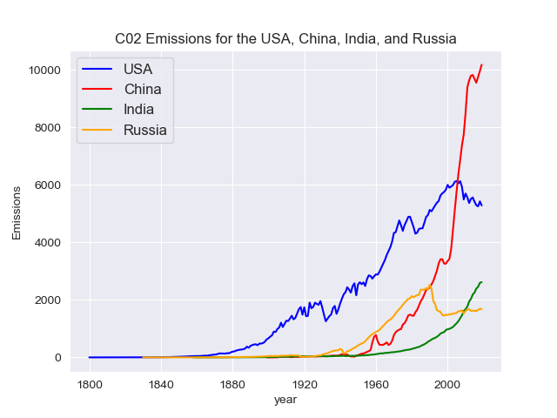

China’s CO2 emissions grew parabolically after the turn of the century while emissions in the US declined for the same period. This is probably an effect of decreasing manufacturing in the US and increasing manufacturing in China. During the same time, China regularly became the US’s largest trading partner (excluding the European Union as a single entity). The dip is Russia’s emissions correlate to the fall of the Soviet Union. India’s emissions continue to rise constantly albeit at a reduced rate compared to the US and China.

Because of the magnitude of their emissions and unique relationship, the remainder of this analysis will focus on the US and China. Although the twitter data specifically focused on US sentiment regarding global warming, China’s exports play a huge role in US consumption. The next step in the analysis is to view Chinese and US emissions on a per-capita basis while comparing them to US per-capita consumption. View the following graph:

Figure 11

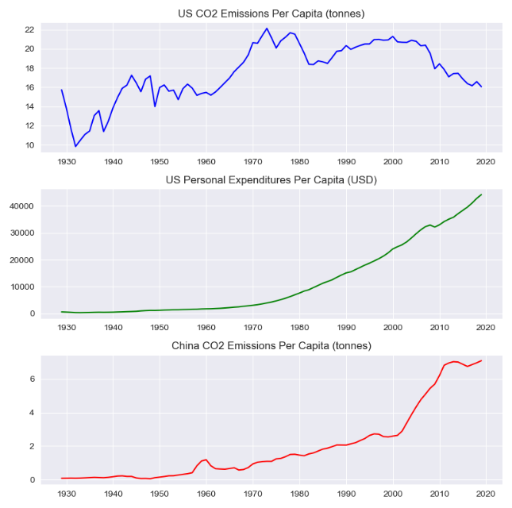

US per-capita emissions are represented by the top graph and Chinese per-capita emissions are represented by the bottom graph. Per-capita US consumption are tucked in the middle graph. The consumption data represent consumption expenditure in dollars. The correlation coefficient between US per-capita emissions and US per-capita consumption is 0.382. However, the correlation coefficient between US per-capita consumption and Chinese per-capita emissions is 0.97. US consumption is heavily positively correlated with Chinese emissions. This is not to indicate US consumption caused the exponential increase in emissions in China, just to say the two are correlated.

The results from the sentiment analysis showed from 2016 to 2020 the sentiment of tweets regarding climate change became less positive and more neutral. During that same time, US consumption continued to increase along with Chinese emissions while US emissions dropped. However, it should be noted that US per-capita emissions are much higher than Chinese per-capita emissions regardless of the decreasing rate over the time. The key takeaway from exploring this data is that behavior in the US has remained consistent while sentiment seems to be vacillating. Given the data, how will emissions and consumption continue?

# Data Preparation

Dataset was divided into two datasets one for tweets from CSV and other for FRED APIs. Tweet data was used to predict whether a tweet came from 2016 or 2020, as well as to compare sentiments, the date column was transformed into a column only containing the year 2016 or 2020. This column then was used in analysis as the label variable.

Following activities were performed for the data preparation and cleanup:

1. Removed special characters from the labels and any column name with less than or equal to 3 letters such as “it”, “a”, “xyz” to reduce the vocabulary
2. Removed hashtags & emojis from the tweet text data using “tweepy”
3. Classified source data into categories relevant for indicating the tweets posted by humans vs bots

# Analysis & Models

## Supervised Learning Models

### Naïve Bayes (NB)

Multinomial Naïve Bayes models (MNB) is a probabilistic classifier that uses word frequencies to solve classification problems. In the induction step, the prior probabilities (percentage of documents belonging to each category) and all the conditional probabilities are calculated and stored. In the deduction step, the model will classify new documents based on the category with the highest posterior probability. Smoothing is also important, especially in text classification, because it keeps posterior probabilities from being zero.

### Support Vector Machine (SVM)

SVM uses a linear boundary to separate and, therefore, classify data. Luckily, many text classifications problems are linearly separable. If data cannot be classified linearly, SVMs have a kernel parameter that can transform linear data into a higher dimension. The kernels being used are Polynomial and Radial-basis function (RBF) kernels. An important component of SVM modeling are the margins, which are controlled by the cost parameter. If cost is too small, the model’s margins will be too large, and the model will be a poor classifier. On the other hand, if cost is too large, the model’s margins will be too small, and the model will overfit the training data.

## Sentiment Analysis

### VADER Sentiment Analysis

VADER is a lexicon that calculates document sentiment based on words within the document. Sentiment scores were compounded, and each document was labeled as positive, negative, or neutral. Positive labeled documents have a sentiment score greater than 0; Negative labeled documents have a sentiment scores less than 0; and Neutral labeled documents have a sentiment score of 0.

### Latent Dirichlet Allocation (LDA) for Topic Modeling

Latent Dirichlet Allocation (LDA) for Topic Modeling was used to categorize the documents into general topics. Each topic is a distribution of the collection’s vocabulary – all the words from all the articles. In short, every topic has the same number of words, however, their frequencies are different. These differences allow the LDA algorithm to identify general themes in a text collection.

## Time Series Analysis

### Auto-Regressive Moving Average Model (ARMA)

An auto-regressive model regresses values of a time series against previous values of the same time series. A moving average model regresses values of a time series against previous shock values of the same time series. The ARMA model is the combination of an AR and MA model on the same time series.

# Results

### Naïve Bayes for Predicting Year of Text

A Multinomial Naïve Bayes was built to predict the year a tweet was made, 2016 or 2020. Running the model using SKlearn’s default parameters on the full dataset with 400 tweets labeled 2016 and 397 tweets labeled 2020 yielded results indicative of overfitting with an accuracy score of 98%. To resolve this issue the data was sampled using multiple parameters for comparison of the models’ accuracy and number of mislabeled tweets. The table below reveals the outcomes of the different sampling parameters. The row in red includes the sampling parameters chosen for final model, due to high Accuracy, but not so high it lends to belief of overfitted data.

|  |  |  |  |  |
| --- | --- | --- | --- | --- |
| Number of Records to Return | Random State | Replace | Model Accuracy | Number Mislabeled by Model |
| 800 | 0 | True | 99% | 4 |
| 200 | 0 | False | 94% | 7 |
| 200 | 2 | False | 95% | 5 |
| 200 | 3 | False | 95% | 5 |
| 350 | 0 | False | 94% | 9 |
| 350 | 2 | False | 96% | 7 |
| 350 | 3 | False | 97% | 5 |

### Support Vector Machine for Predicting Year of Text

A Support Vector Machine model was built as a second method for classifying a tweet as being written in 2016 or 2020. Much like the issue of overfitting that the Naïve Bayes model had prior to sampling, the SVM model had an accuracy score of 99% indicating potential error in data overfitting. Based on the decision to use the sampling parameters of n=350, random_state=2, and replace=False in the Naïve Bayes analysis, this same sampled data was used in training and testing the support vector machine. Three kernels were used to build different SVM models to choose the strongest model. The table below reports the kernels used and the accuracy scores they yielded. The model in red is the model chosen upon comparison.

|  |  |  |  |  |
| --- | --- | --- | --- | --- |
| SVM Kernel | Regularization (c) | Degree | Gamma | Accuracy Score |
| linear | 1.0 | 3 | auto | 99% |
| linear | 10.0 | 3 | auto | 98% |
| rbf | 10.0 | 3 | auto | 81% |
| poly | 10.0 | 3 | scale | 94% |

### MNB and SVM for Predicting Sentiment in 2016 Tweets

Using VADER, each tweet text (document), from the 2016 tweets about global warming, were labeled as negative, neutral, and positive, depending on their sentiment score. There were 811 negative, 1389 neutral, and 2800 positive tweets. To balance the dataset, 800 texts were sampled from each sentiment classification. If the labels were not balanced, subsequent models would favor whichever label appeared the most. For example, if the dataset contained 2800 positive and 811 negative tweet texts, the models would be very good at predicting positive sentiment, however, fail at predicting negative sentiment.

After balancing the dataset, MNB and SVM models were trained to predict the overall sentiment of a tweet’s text. For SVM models, cost was tuned, for each kernel, to maximize the model’s accuracy. Since the length of each document varied, it was important to normalize the data, using a TfidfVectorizer, to compare how well the models performed on term frequency and normalized labeled data frames. The figure below are the average model accuracies after 5-fold cross validation:

Figure 12

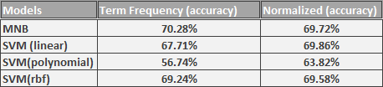

The model with the highest accuracy was MNB on term frequency data, however, SVM models performed better on normalized data. Furthermore, SVM (polynomial kernel) on a normalized text collection had an accuracy 7.08% higher than the data frame of term frequencies, which meant the normalized text data was easier to classify at a higher dimension.

Next, confusion matrices were created to analyze how well MNB and SVM models predicted each class. Specifically, 1-fold cross validation on the term frequency data frame:

From the confusion matrix below, the MNB model was more accurate at predicting positive tweets than negative or neutral tweets.

Figure 13

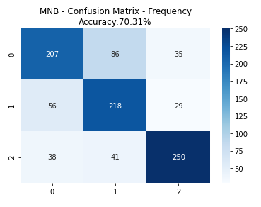

Like the MNB model, the SVM (linear kernel) confusion matrix below, as well as SVM (rbf kernel), was more accurate at positive tweet prediction. Negative and neutral tweets were predicted at roughly the same rate.

Figure 14

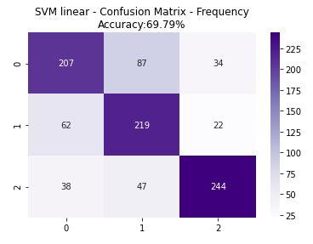

Unlike the MNB model, the SVM (polynomial kernel) confusion matrix below was more accurate at predicting neutral tweets than positive or negative tweets. The model made the mistake of classifying positive and negative tweets as neutral.

Figure 15

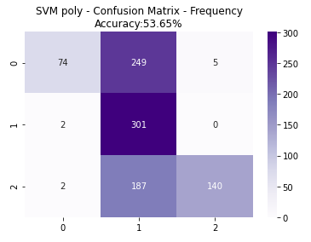

Next, to assess what the MNB classifier learned, features and their coefficients were retrieved from the classifier’s components. The figure below are some highly weighted words the classifier used to make predictions. Due to the broadness of the neutral tweets, LDA will be used to discover general themes about them. After analyzing the words, the positive words appear to be about an actor’s speech. The negative words appear to be much broader, in the scope of global warming, giving more weight to words like illuminati, war, and fracking, for prediction.

Figure 16

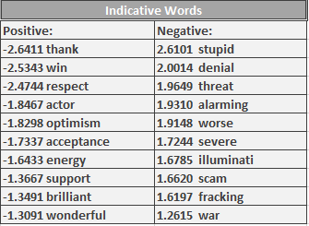

LDA was used to discover some of the overarching themes present in the positive, negative, and neutral tweets. The data was also vectorized as bigrams to provide more context. In the figure below, LDA created three topics to generalize the positive tweets.

Figure 17

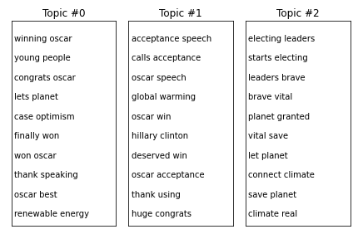

Afterwards, LDA created three topics from the neutral tweets:

Figure 18

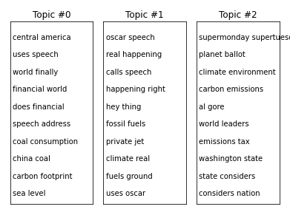

Lastly, LDA created three topics from the negative tweets:

Figure 19

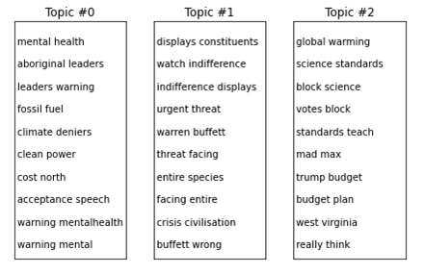

Positive topics were primarily about an Oscars speech and were optimistic towards renewable energy research. Some of the general topics, found in neutral tweets, were coal consumption, tax on emissions, and fossil fuels. Negative topics emphasized mental health, the looming threat of global warming, and standards in science.

Finally, to identify any changes in sentiment over four years, both the 2016 tweets and 2020 tweets were analyzed using TextBlob’s sentiment analysis library. After the sentiment scores were yielded, the average of each data set’s scores was calculated. The results, shown in the figure below, indicate that sentiment about climate change has become less positive than in 2016.

|  |  |
| --- | --- |
| **Average Sentiment Score for 2016 Tweets** | **Average Sentiment Score for 2020 Tweets** |
| **0.1** | **0.04** |

### ARMA for Predicting Future Emissions and Behaviors

Auto Regressive Moving Average (ARMA) models were used to forecast future values of US consumption and emissions as well as Chinese emissions. The first step in the modeling process was to view the autocorrelation functions for the three separate time series to be modeled. Here is the autocorrelation function (ACF) and partial autocorrelation function (PACF) for US per-capita emissions:

Figure 20

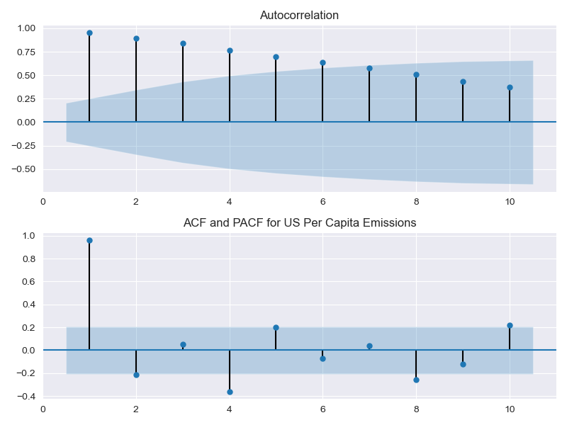

The lags are tailing off in the ACF (top graph) while the lags in the PACF cut off after the first lag. Here is the ACF and PACF for US per-capita consumption:

Figure 21

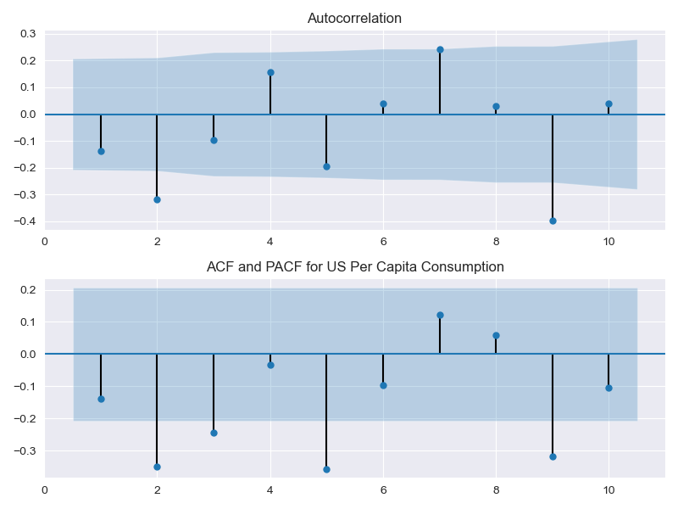

There doesn’t seem to be a pattern outside of some significant lags in the graphs above. Here is the ACF and PACF for Chinese per-capita emissions:

Figure 22

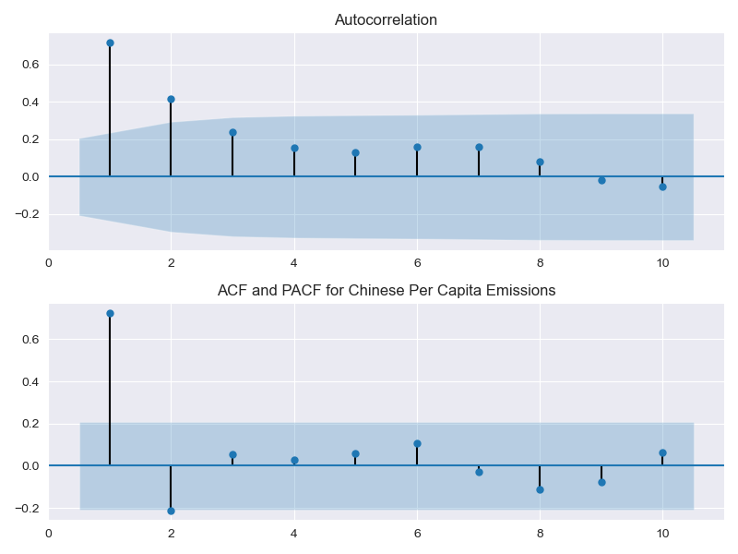

The ACF plots give an idea of what parameters to use for modeling. Python’s auto-arima method was used to determine optimal model parameters. The US emissions and consumption time series was fit using an ARMA(1,3) model. The Chinese emissions time series was fit using an ARMA(1,1) model. Here are the resulting graphs from fitting the models and plotting the predicted values:

Figure 23

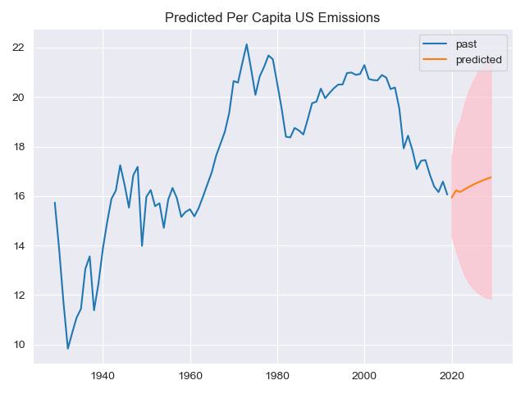

Figure 24

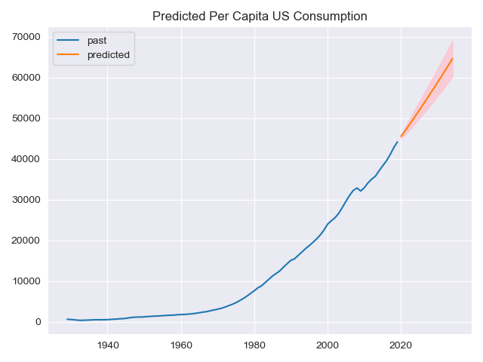

Figure 25

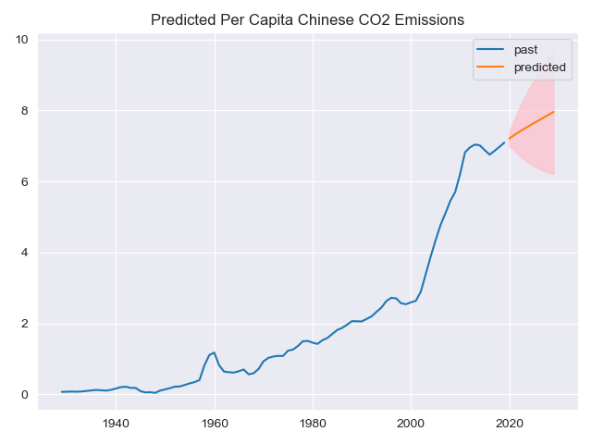

The pink shaded areas in the graphs represent the confidence intervals. The two graphs predicting future emissions have more uncertainty, hence the wider confidence intervals. The model predicting future US consumption has far less uncertainty than the other two models. All else equal, the models are predicting all three measures to rise in the next five years or so.

# Conclusions

When the term g*lobal warming* entered the lexicon in 1975, how could society have known that this term and its more preferred successor *climate change* would become a divisive topic, often debated by politicians, actors, and even strangers online? Likewise, when Twitter launched in March of 2006 as a short-text platform for users to speak their mind, did anyone have anticipated the platform would become an invaluable time capsule? Regardless of anyone’s forethought, thanks to Twitter and the freedom users have felt to post their thoughts under a cloak of pseudo anonymity, analysis of users’ genuine beliefs surrounding climate change and trends in sentiment is possible.

In 2016, a key driver of public sentiment, regarding global warming, was Leonardo Dicaprio’s speech on climate change, which garnered the attention of 34.4 million viewers. In his speech, Dicaprio stressed the need to support strong leaders who will combat global warming, not deny it. Interestingly, the speech did not provoke anymore news reports about climate change, however, on twitter, hashtags like “climate change” and “global warming” were being used considerably more. Other platforms, such as Google Trends, were used to identify how impactful the speech was on public sentiment. Unfortunately, changes in public sentiment do not guarantee changes in public behavior, so more research about the speech’s societal influence is necessary.

Besides Dicaprio, Hillary Clinton, Al Gore, and Trump were among the most prominent people, regarding global warming, back in 2016. Clinton and Gore supported the Paris Climate Agreement - an agreement between the United Nations to reduce greenhouse gas emissions worldwide. After winning the presidential election, however, Trump withdrew the United States from the agreement in 2017. The withdrawal was heavily covered in the media, however, more research needs to be done to determine how influential it was on twitter and Google Trends.

Another important topic was global warming and how it can affect mental health. There are several likely instances where mental health is worsened by global warming. For instance, as global warming increases, the intensity and occurrence of torrential rains are likely to increase, which causes frequent flooding. People in flood-prone areas will be forced to evacuate, which could lead to acculturation stress. Studies have shown that people involuntarily moved from their home, from a disaster, are more likely to develop a mental illness than those who chose to migrate. In recent news, over 18,000 people have been evacuated from their homes due to flooding in New South Wales, Australia. It is important that mental health and financial services are available to help mitigate any mental health issues.

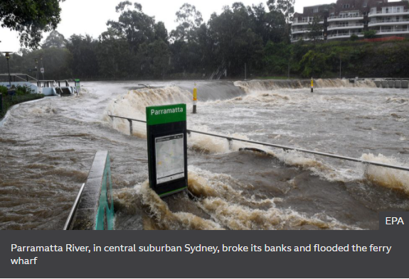

**Lessons Learnt**

* Data familiarity is the key when it comes to deducing results for a topic. As we had a clear distinction of the dataset and what we were trying to achieve, it was easier to filter out more advertising related tweets which could have adulterated the dataset
* Extra efforts were needed to balance the data to ensure there were no bias in the conclusions & predictions
* Accuracy level for the real-world dataset is way less than the training datasets used as firstly it is unstructured and secondly it is hard to deduct the anomalies in the dataset

**References**

Australia floods: Thousands evacuated AS downpours worsen. (2021, March 22). Retrieved March 25, 2021, from <https://www.bbc.com/news/world-australia-56476998>

Bhugra, D., & Jones, P. (2001). Migration and mental illness. *Advances in Psychiatric Treatment,* *7*(3), 216-222. doi:10.1192/apt.7.3.216

Black, R. (2013, September 20). *A Brief History of Climate Change*. Retrieved from bbc.com: <https://www.bbc.com/news/science-environment-15874560#:~:text=1975%20%2D%20US%20scientist%20Wallace%20Broecker,title%20of%20a%20scientific%20paper>.

Overview: Weather, global warming and climate change. (2021, January 28). Retrieved March 20, 2021, from <https://climate.nasa.gov/resources/global-warming-vs-climate-change/>

Harrington, R. (2016, October 05). Where Hillary Clinton and Donald Trump stand on climate change. Retrieved March 25, 2021, from <https://www.businessinsider.com/clinton-trump-environment-policies-plans-climate-change-platforms-2016-9>

Hoffman, A. (2016, August 05). Leonardo DiCaprio: Oscars Speech Spurs climate change talk. Retrieved March 25, 2021, from <https://time.com/4441219/leonardo-dicaprio-oscars-climate-change/#:~:text=%E2%80%9CA%20single%20speech%2C%20at%20a,addition%20to%20celebrities%20with%20causes>

Padhy, Susanta Kumar et al. “Mental health effects of climate change.” *Indian journal of occupational and environmental medicine* vol. 19,1 (2015): 3-7. doi:10.4103/0019-5278.156997